
MECHATRONIC SYSTEM INTEGRATION
(MCTA 3203)

SEMESTER 1, 2026/2027

EXPERIMENT 1

DIGITAL LOGIC SYSTEM

(MCTA 3203)

SECTION 1
GROUP 4

NO. | MATRIC NO. | NAME
1 | 2413381 | HARITH NAUFAL BIN AHMAD SHUKRI
2 | 2418123 | IMAN BIN SALMAN
3 | 2411349 | LUQMAN HAKIMI BIN SUHAIZI
4 | 2418929 | MUHAMAD HAZIQ BIN MOHD SHAHRIL

SUBMISSION DATE:

ABSTRACT
This experiment demonstrated digital output control by interfacing a common-anode seven-segment display and two pushbuttons with an Arduino Uno. Pins D2–D8 controlled the display segments using active-LOW logic, while pins D9 and D10 read the count-up and reset buttons using internal pull-up resistors and debounce delays. The key objective of this experiment is to have a digital counter that display numerical value and allow user to increase or reset the displayed number using two separate push buttons.

First, the circuit was built according to the required connections with the display and two pushbuttons connected to the Arduino. The Arduino program was then uploaded, and the counter was initialized at 0. The count-up button was pressed to increase the displayed number and finally, the reset button was tested to ensure the display returned to 0. During testing, the circuit operated reliably without issues: pressing the count-up button incremented the displayed number from 0 to 9, and the reset button cleared it back to 0.

The challenges that we overcame during the experiment included connecting the circuit correctly and ensuring that all components were properly connected to the Arduino. We solved these issues by checking the wiring connections carefully and correcting any mistakes. Potential future improvements include writing modular segment-control code, adding software debouncing, and expanding the design to multi-digit displays so it can count higher numbers more accurately and reliably.

TABLE OF CONTENTS
ABSTRACT 2
TABLE OF CONTENTS 3
INTRODUCTION & THEORY 4
MATERIALS AND EQUIPMENT 5
EXPERIMENTAL SETUP 6
METHODOLOGY & PROGRAMMING LOGIC 7
DATA COLLECTION 8
DATA ANALYSIS 9
CODE 9
RESULTS & DISCUSSION 10
CONCLUSION 10
RECOMMENDATIONS 10
REFERENCES 10
APPENDICES 10
ACKNOWLEDGEMENT 10
STUDENT DECLARATION 10

INTRODUCTION & THEORY
A seven-segment display consists of seven individual segments labelled A to G. Different combinations of these segments are used to display numbers from 0 to 9.
In this experiment, an Arduino Uno was used to control a common-anode seven-segment display. Since the display is common-anode, a LOW signal turns a segment ON, while a HIGH signal turns it OFF.
Two pushbuttons were used to control the display. One button increases the displayed number, while the other resets the counter to 0.
The objective of this experiment was to interface the seven-segment display and pushbuttons with the Arduino and produce a working 0–9 counter.

MATERIALS AND EQUIPMENT
The following components were used:
- Arduino Uno
- Common-anode 7-segment display
- 7 × 220 Ω resistors
- 2 × pushbuttons
- Breadboard
- Jumper wires
- Laptop with Arduino IDE

EXPERIMENTAL SETUP
- The seven-segment display was connected to the Arduino using the following pins:
Segment | Arduino Pin
A | D4
B | D5
C | D8
D | D7
E | D6
F | D3
G | D2
- The two pushbuttons were connected as follows:
Function | Arduino Pin
Count Up | D9
Reset | D10

- The display segments were connected through 220 Ω resistors to limit the current.
- The pushbuttons are connected to 5V alongside ground and the inputs are connected opposite of it.
- 10K-ohm pull-up resistors are used for each pushbutton by connecting one end of each resistor to the digital pin and the other end to the 5V output of the of the Arduino.

- Hardware configuration instructions.
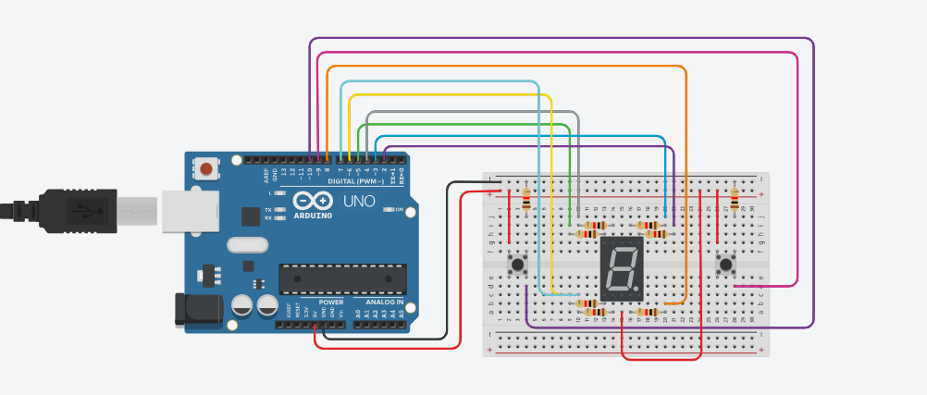

METHODOLOGY & PROGRAMMING LOGIC
The experiment was carried out by:
- Building the circuit according to the required connections.
- Connecting the seven-segment display and two pushbuttons to the Arduino.
- Uploading the Arduino program.
- Starting the counter at 0.
- Pressing the count-up button to increase the displayed number.
- Testing the counter from 0 to 9.
- Pressing the reset button to return the display to 0.
The function controls which segments are ON or OFF for each number.
The count-up function uses:
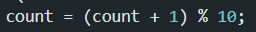
This makes the counter return to 0 after reaching 9.
The reset function uses:
A 200 ms delay is included after each button press to reduce button bouncing.

DATA COLLECTION
- The seven-segment display successfully showed all digits from 0 to 9 in sequence.
- The digital output states (HIGH or LOW) act as the data sent to pins D2-D8 to turn each LED segment on or off.
- The Serial Monitor functions (Arduino IDE) as the data acquisition instrument, tracking the digital state shifts caused by the increment and reset actions.

DATA ANALYSIS
A common-anode 7-segment display requires LOW voltage signals to illuminate specific segments. By controlling the combination of LOW and HIGH states across the seven digital pins, different numerical patterns are formed. For example, setting segments A, B, C, D, E, and F to LOW while keeping segment G HIGH displays the number 0.
The pushbuttons successfully changed the internal logic states of the Arduino, allowing the count-up button to increase the displayed number and the reset button to return the display to 0.

CODE
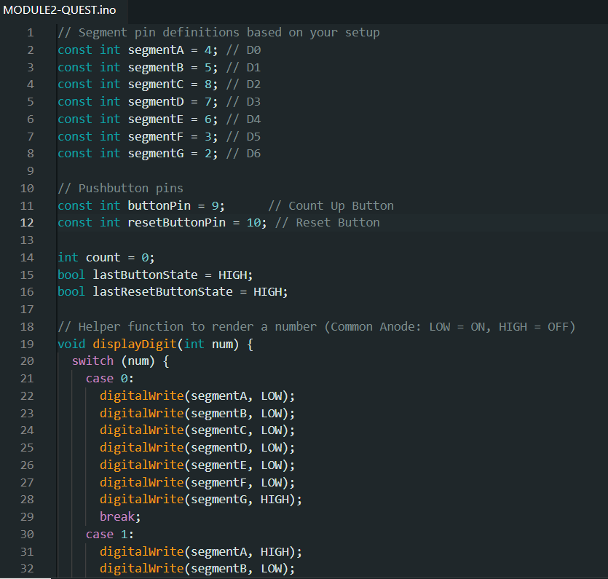
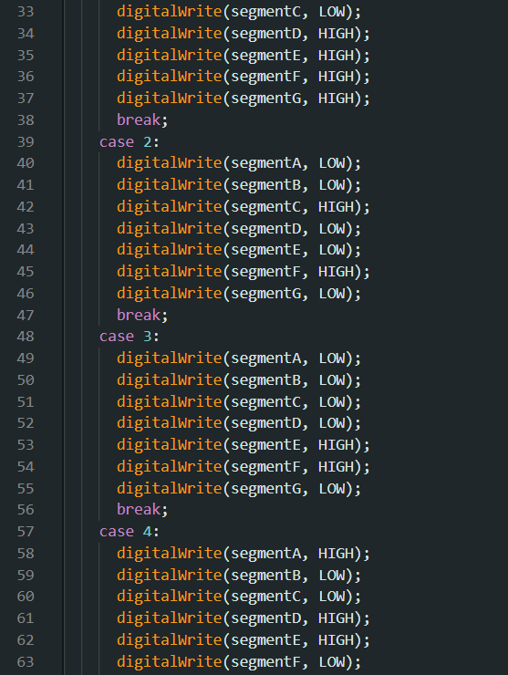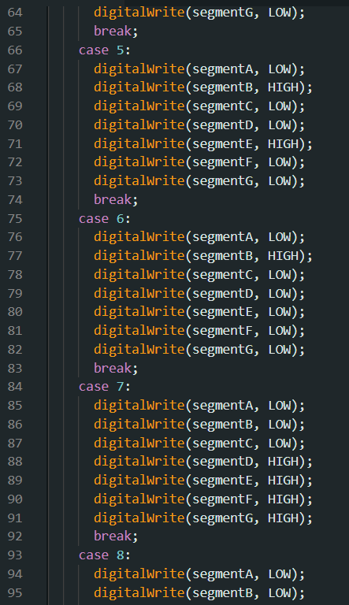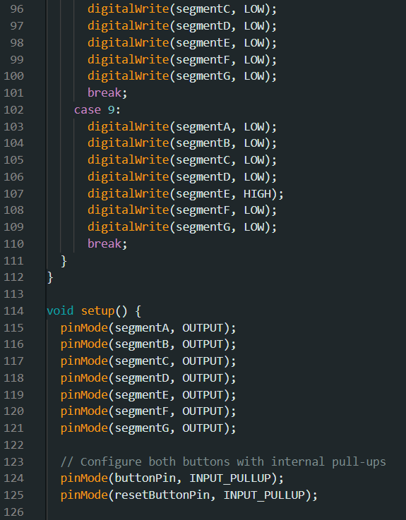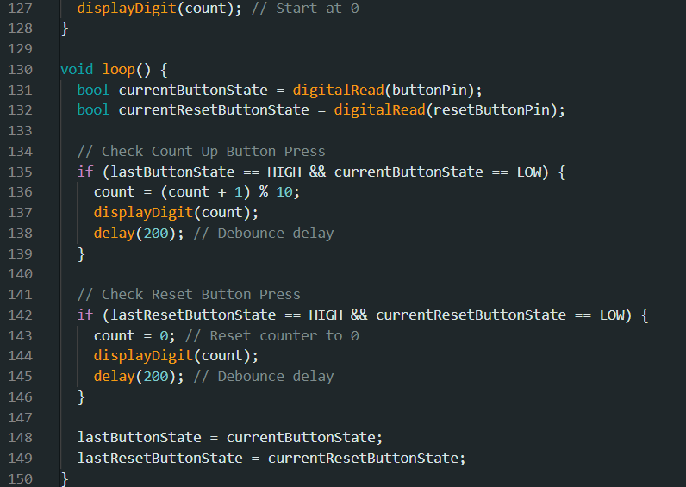

RESULTS & DISCUSSION
The experiment was successfully completed. The seven-segment display displayed the numbers from 0 to 9 correctly.
The count-up button successfully increased the displayed number, while the reset button returned the display to 0. No significant problems were encountered during testing.
The common-anode configuration required LOW signals to activate the display segments. Therefore, the program was written according to the active-LOW operation of the display.
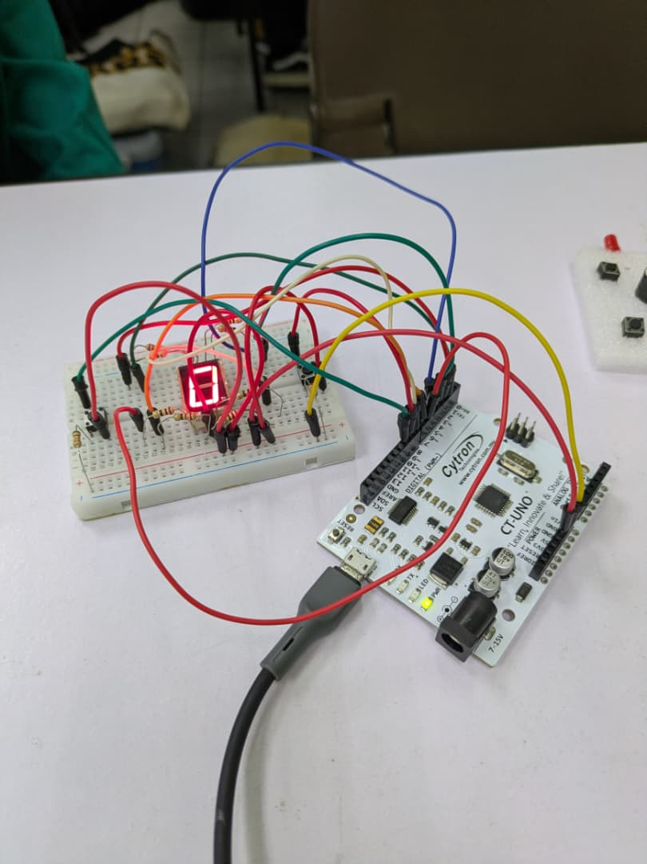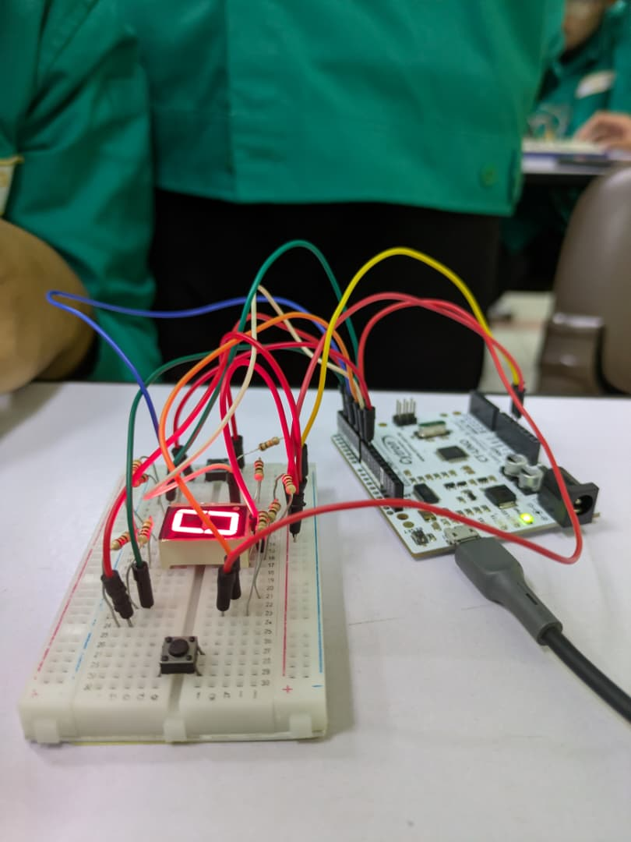
Visual evidence:
https://drive.google.com/drive/folders/1OyrHAU-J05q-vPYV7gfLzClhoJEGqY_4?usp=drive_link
Questions:
How can you interface an I2C LCD with Arduino? Explain the coding principle behind it compared to a 7-segment display and a matrix LED.
Answer:
An I²C LCD can be connected to an Arduino using two communication lines: SDA and SCL. For an Arduino Uno, SDA is connected to A4 and SCL is connected to A5.
Unlike the seven-segment display, which requires individual digital pins to control each segment, an I²C LCD receives commands and data through the I²C communication protocol.
A matrix LED uses rows and columns to control multiple LEDs and can display different patterns or characters.

CONCLUSION
The experiment successfully demonstrated how an Arduino Uno can be used to control a seven-segment display and pushbuttons.
The display successfully showed numbers from 0 to 9, while the two buttons controlled the counting and reset functions. The experiment also provided an understanding of digital output control and the difference between common-anode and common-cathode displays.

RECOMMENDATIONS
- The system can be improved by adding more seven-segment displays to show larger numbers.
- The program could also be modified to include automatic counting or different counting modes.
- Use arrays to simplify the number of display coding.

REFERENCES
- Viral Science - The home of Creativity. (2019, February 2). Arduino Seven Segment Display Counter | Push Button | Code Explanation. YouTube. https://www.youtube.com/watch?v=jtmUxgDf6uI
- Fuller, J. (2023, March 4). Button Count on LCD – Arduino Tutorial. Circuits DIY. https://www.circuits-diy.com/button-count-on-lcd-arduino-tutorial/

APPENDICES
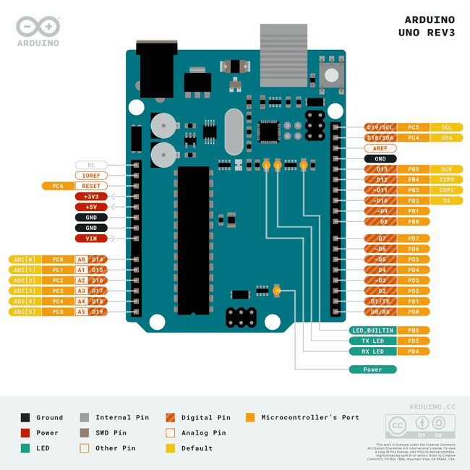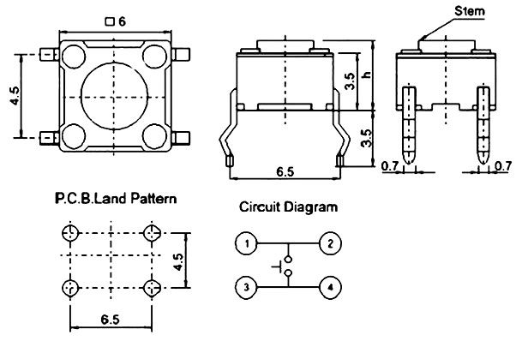

ACKNOWLEDGEMENT
We would like to express our deepest appreciation to our instructor and lab personnel for their guidance and support throughout this experiment.

STUDENT DECLARATION
Certificate of Originality and Authenticity

This is to certify that we are responsible for the work submitted in this report, that the original work is our own except as specified in the references and acknowledgments, and that the original work contained herein has not been undertaken or done by unauthorized sources or persons.

SIGNATURE | STUDENT DETAILS | CHECKLIST
 | Name: Harith Naufal Bin Ahmad Shukri  Matric No: 2413381 | Read [/]  Understand [/]  Agree [/]
 | Name: Iman Bin Salman  Matric No: 2418123 | Read [/]  Understand [/]  Agree [/]
 | Name: Luqman Hakimi Bin Suhaizi  Matric No: 2411349 | Read [/]  Understand [/]  Agree [/]
 | Name: Muhamad Haziq Bin Mohd Shahril  Matric No: 2418929 | Read [/]  Understand [/]  Agree [/]

